Lab3: Google Word Search

# The objective of this lab is to

* Call PHP using AJAX
* Display your PHP output using HTML

# Goal

Create an interface page where the user can look up words.

### Where to query:

* <https://tmrudwick-web.herokuapp.com/SearchQuery/search.php?query=thlet>
  + Note that the query is up to you.
* **Use an AJAX call, similar to what we discussed in class.**

Possible output:

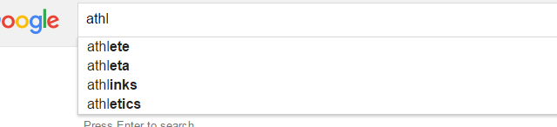

The results that are generated by php should be displayed with html / formatting

# Order of the lab:

1. Simply query the database based on your input, and display the output. Feel free to use a button for this.
2. Remove the button (have it query when you type in something).
   1. Then add a delay to the search. That is, don’t search until the user stops typing.
3. Limit the number of returned values.

# Extensions (note that these are not in order):

1. Create your own search engine using PHP
   1. I simply used a textfile to keep my searches
   2. Feel free to query something other than words.
      1. Some ideas: Most popular google searches?
2. Save the user inputted values and graphically display them somehow
3. Using some sort of word API, query the definitions to look them up and display them somehow.

References:

* <http://www.w3schools.com/ajax/ajax_xmlhttprequest_send.asp>
* <http://www.w3schools.com/ajax/ajax_php.asp>